SIMATS ENGINEERING
SAVEETHA INSTITUTE OF MEDICAL AND TECHNICAL SCIENCES
CHENNAI – 602105
Department of Computer Science and Engineering

ASSESSMENT TOOL 2 – Application-Based Questions

Course Code: | DSA05 | Course Title: | Query Processing for Data Science With Real Time Applications
CO Assessed: | CO1 | Assessment: | Tool 2 – Application-Based Questions
Weightage: |  | Total Marks: | 20 Marks
CO2 Statement: Use Python basics and SQL libraries to connect to databases SQLite, MySQL, PostgreSQL and perform CRUD operations like Create, Read, Update, Delete. (BTL6)
Student Name: | G Rajasekhar Reddy | Reg. No.: | 192424216
Section / Batch: | BTech-AI&DS | Date of Submission: | 25-07-2026
Faculty In-charge: | Dr. B. Shyamala Gowri | Project Mode: | Individual Submission

Code of Conduct
I G .Rajasekhar Reddy(192424216) (Name / Reg No) certify that this submission is my original work and that I have adhered to all guidelines specified for this assessment. I understand that any violation of academic integrity rules will result in disciplinary action.
Signature: G. Rajasekhar Reddy

27. Student Performance Analysis:

A college stores student details in students.csv containing Name, Roll Number, Department, and Marks.
Task:
- Read the dataset.
- Calculate the average marks. Add a new column named Result (Pass/Fail) based on a passing mark of 40.
- Display the students who scored above the class average.
- Save the updated dataset.

Program:
import pandas as pd

data = pd.read_csv("students.csv")

average_marks = data["Marks"].mean()

print("Average Marks:", average_marks)

data["Result"] = data["Marks"].apply(lambda x: "Pass" if x >= 40 else "Fail")

above_average = data[data["Marks"] > average_marks]

print("\nStudents Above Class Average:")
print(above_average)

data.to_csv("updated_students.csv", index=False)

print("\nUpdated dataset saved successfully.")

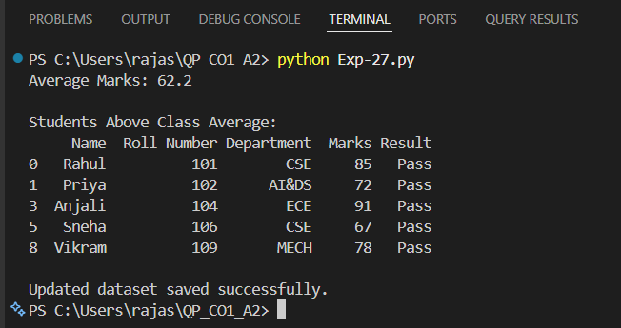
Output:

29. Customer Data Processing (JSON)

Customer information is stored in customers.json.
Task:
Read the JSON file.
Display all customer names.
Find customers from Chennai.
Count the total number of customers.
Export the filtered customer data into a new JSON file

Program:
import pandas as pd
data = pd.read_json("customers.json")

print("Customer Names:")
print(data["Name"])

chennai_customers = data[data["City"] == "Chennai"]

print("\nCustomers from Chennai:")
print(chennai_customers)

print("\nTotal Customers:", len(data))

chennai_customers.to_json("chennai_customers.json", orient="records", indent=4)

print("\nFiltered data saved successfully.")

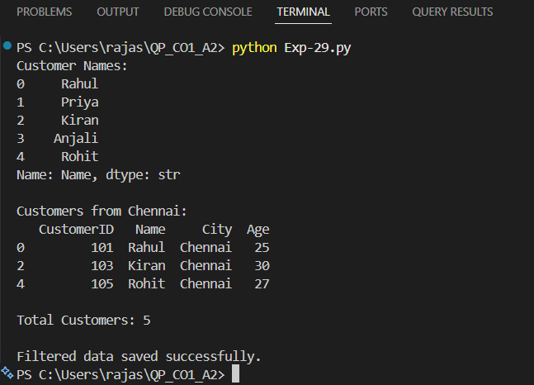
Output:

